SplashGL - v5.4 - Key Features

SplashGL v5.4 introduces a number of enhancements and improvements to the functionality.
The items to be covered in this document are as below:
- AutoFit – default setting: off
- Bursting Templates
- Distribution Templates

AutoFit - default setting: off
Previous versions of SplashGL would automatically fit cell columns upon refreshing, by default.
This could be problematic and frustrating for users with bespoke workbooks and set column widths.
The AutoFit checkbox is now unticked by default.
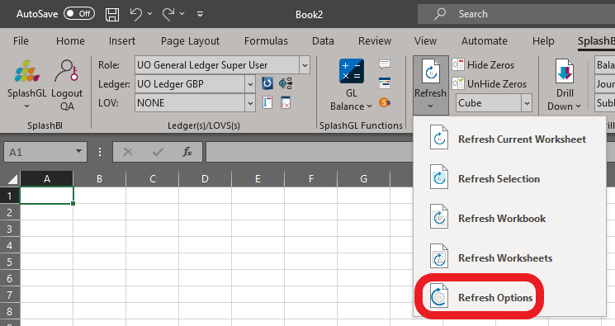

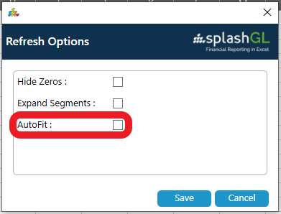

Bursting Templates
Bursting Templates are a defined set of parameters that when executed with the Bursting functionality create a tailored, detailed report in SplashGL.
One aspect of the hierarchy is selected in the Bursting Field, the respective cell on the workbook is referenced appropriately, then the Bursting Direction and Depth Levels are selected.
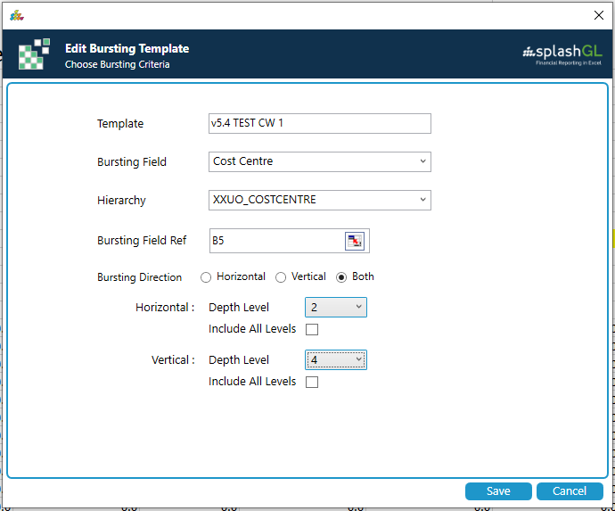

Distribution Templates
Distribution Templates are a defined set of hierarchy values and their respective email recipients of which SplashGL reports can be distributed to.
These can be edited to amend the list of recipients, subject, message body and attached file name.
