SplashBI - Splash plugin installation for Excel (version 5.4)

How to install the Splash XL/GL plug-in for Excel

It is advisable to confirm which version of Excel you have before beginning the installation steps.
To find which version of Excel is present, navigate to File -> Account -> About Excel
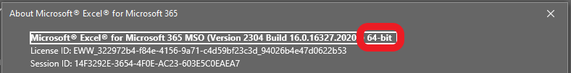
CONNECT users will require 64-bit following the update to Office 2019 on 23rd January 2023.
There is no need to uninstall a previous version of the plugin as this installation will overwrite the existing files, however it will preserve your instance information.
Before installing the SplashBI plugin, ensure that Excel is closed and not running on your device.
Logging into Splash where a mismatch between server and plugin version is present will result in the following error message:
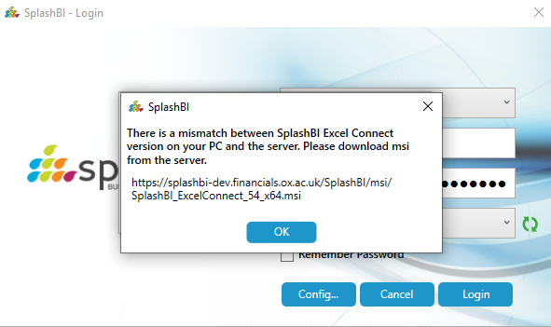

- Log into SplashBI. Under Getting Started is the option to Download Excel Plugin.
Choose the correct version for your Excel as per the prerequisite step and commence the download.
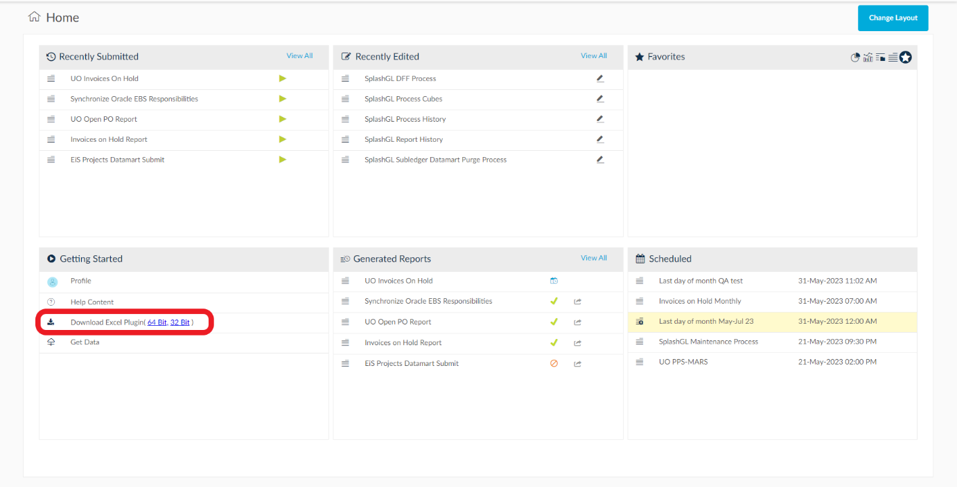

- Click Open to begin the installation process.
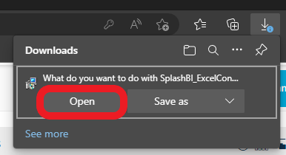

- Navigate through the steps by clicking Next also ensuring that the installation folder is kept as default.
Click Close to complete the setup.
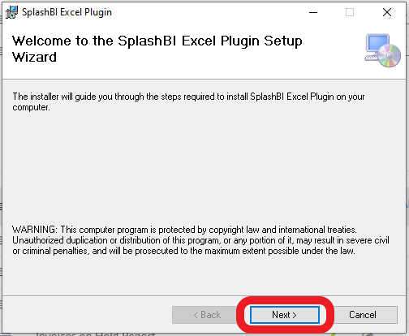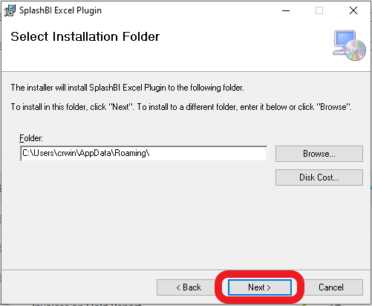
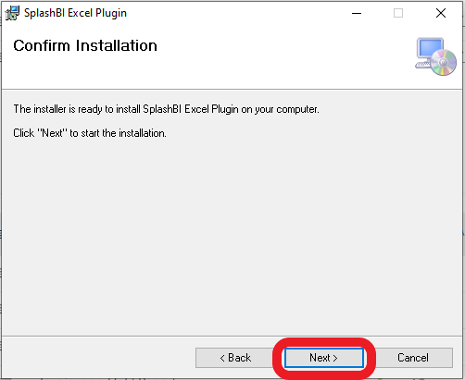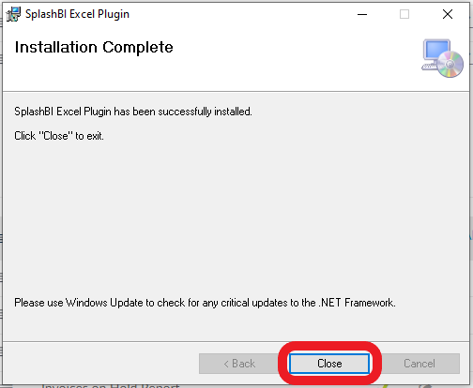

- Run Excel and locate the SplashBI ribbon. Select Login and choose the LIVE instance.
The version should display as Version 5.4 if successfully installed.
