SplashBI - Launching the UO SplashBI responsibility
(Troubleshooting)

If SplashBI is not launching correctly (usually presented by the following error message in a new tab)
First go back to the main Oracle page and try to launch the UO SplashBI responsibility again
(We recommend having SplashBI as a favourite, as shown in the blue ring below. This will allow you to access SplashBI with one click. If you’d like to add SplashBI as homepage icon, select Add Favourites -> Manage Favourites, then select UO SplashBI from the responsibility drop down)
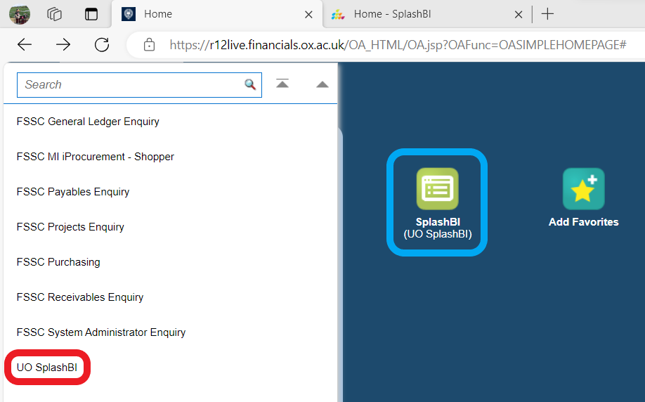
SplashBI should now open successfully in a new tab, however, if the issue persists, please follow the steps below to troubleshoot.

Amending Edge browser settings

- Click the 3 dots to open the menu
- Select Settings
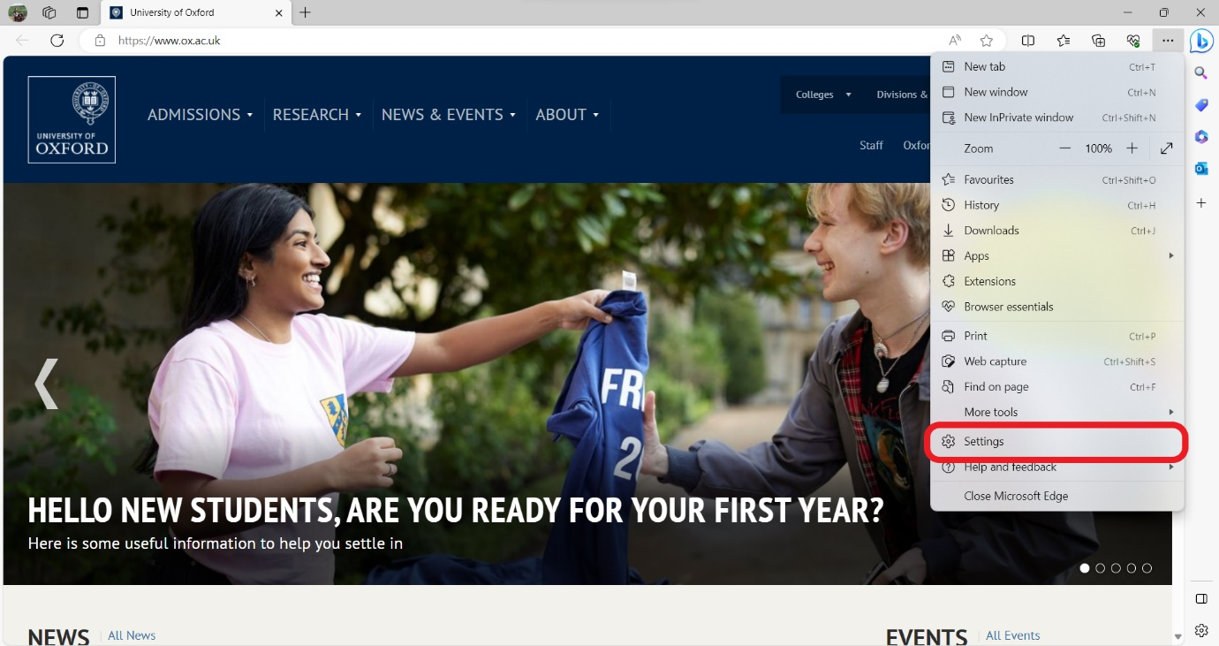
- Select Cookies and site permissions
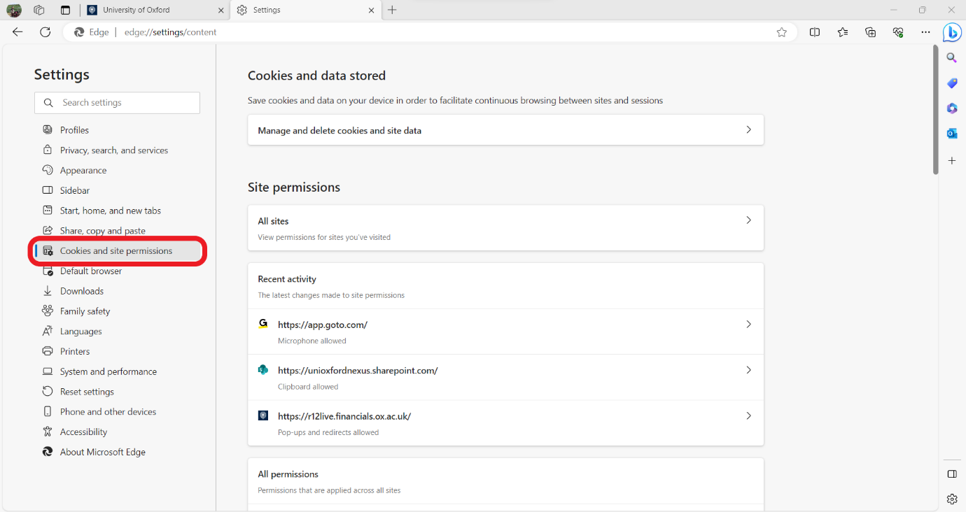
- Scroll down and select Pop-ups and redirects
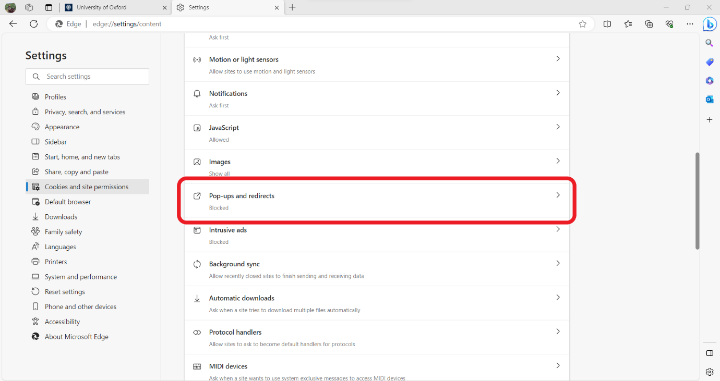
- In the Allow section, click Add
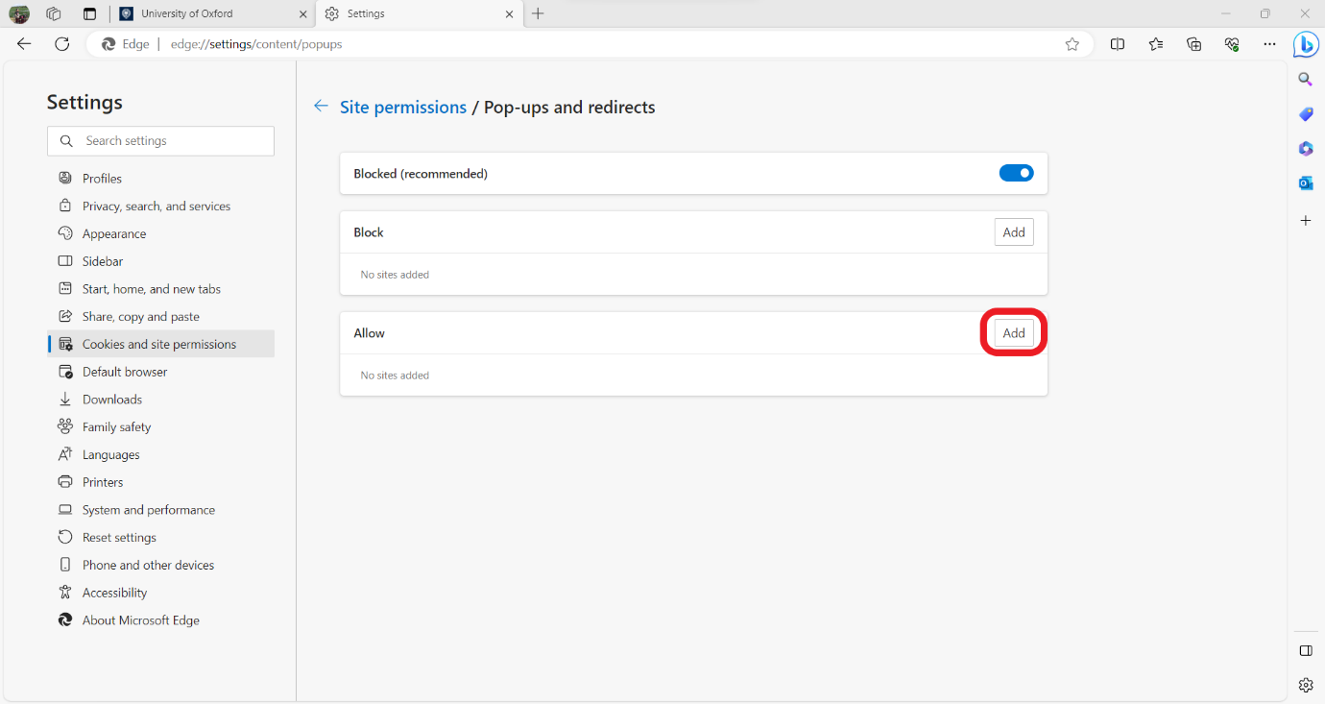
- In the dialog box, enter https://r12live.financials.ox.ac.uk
Click Add
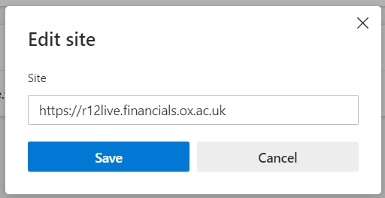
- The site will now be added to the list of allowed sites
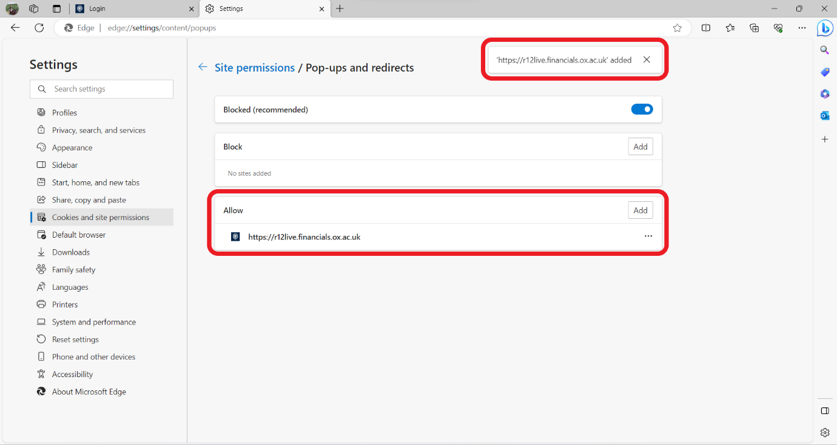

Launching SplashBI from Oracle Forms (Java)

- Once logged into Oracle self-service, select the responsibility menu
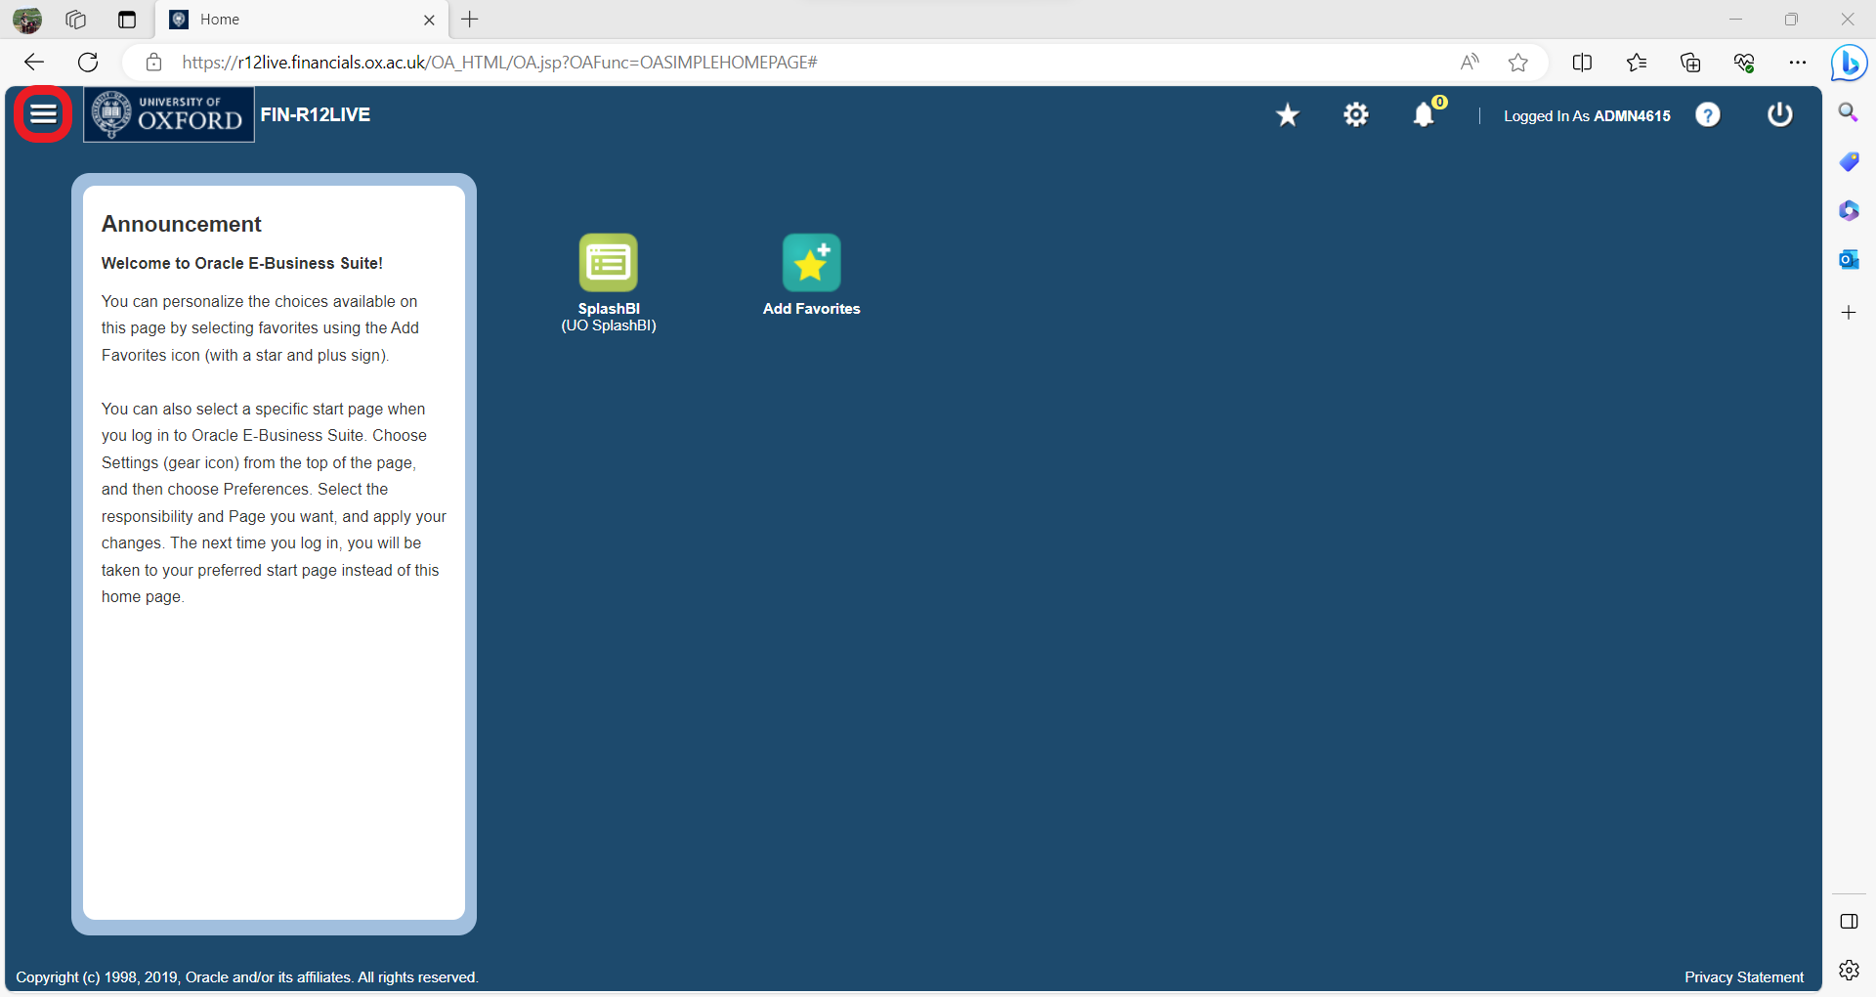
- Select a responsibility that has options to launch Java
In this example we will use a General Ledger responsibility, and launch an Account query
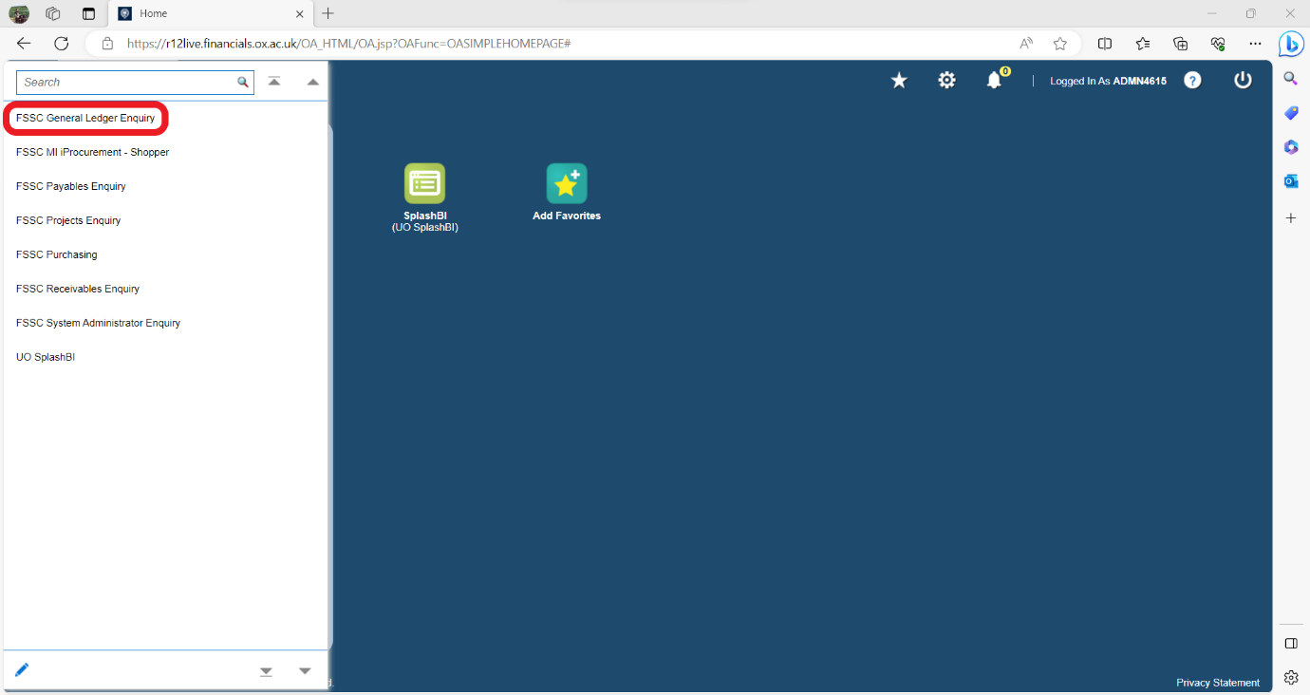
- Select the Account option to launch Java
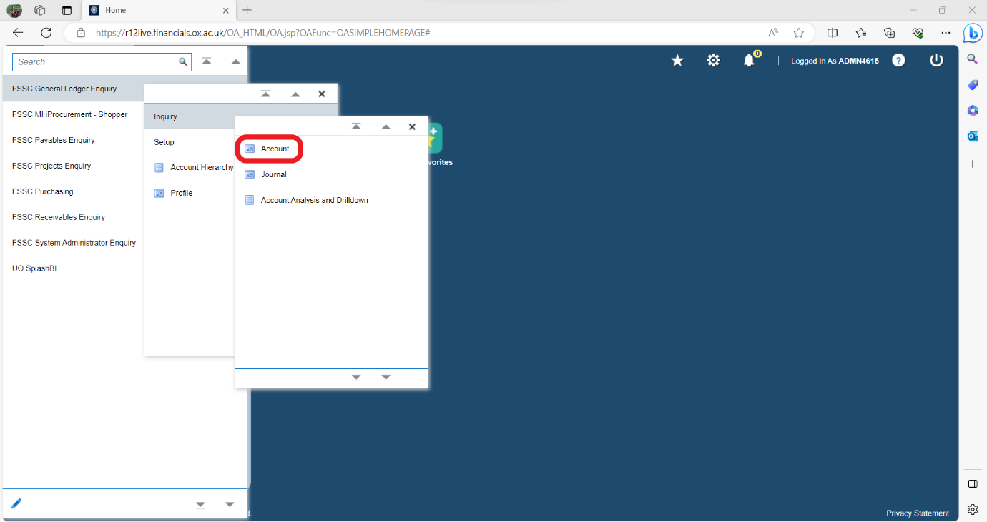
- Select the black hat to change your responsibility.
If the black hat is greyed out, you may need to close any other window in Java so only the Navigator is visible as below
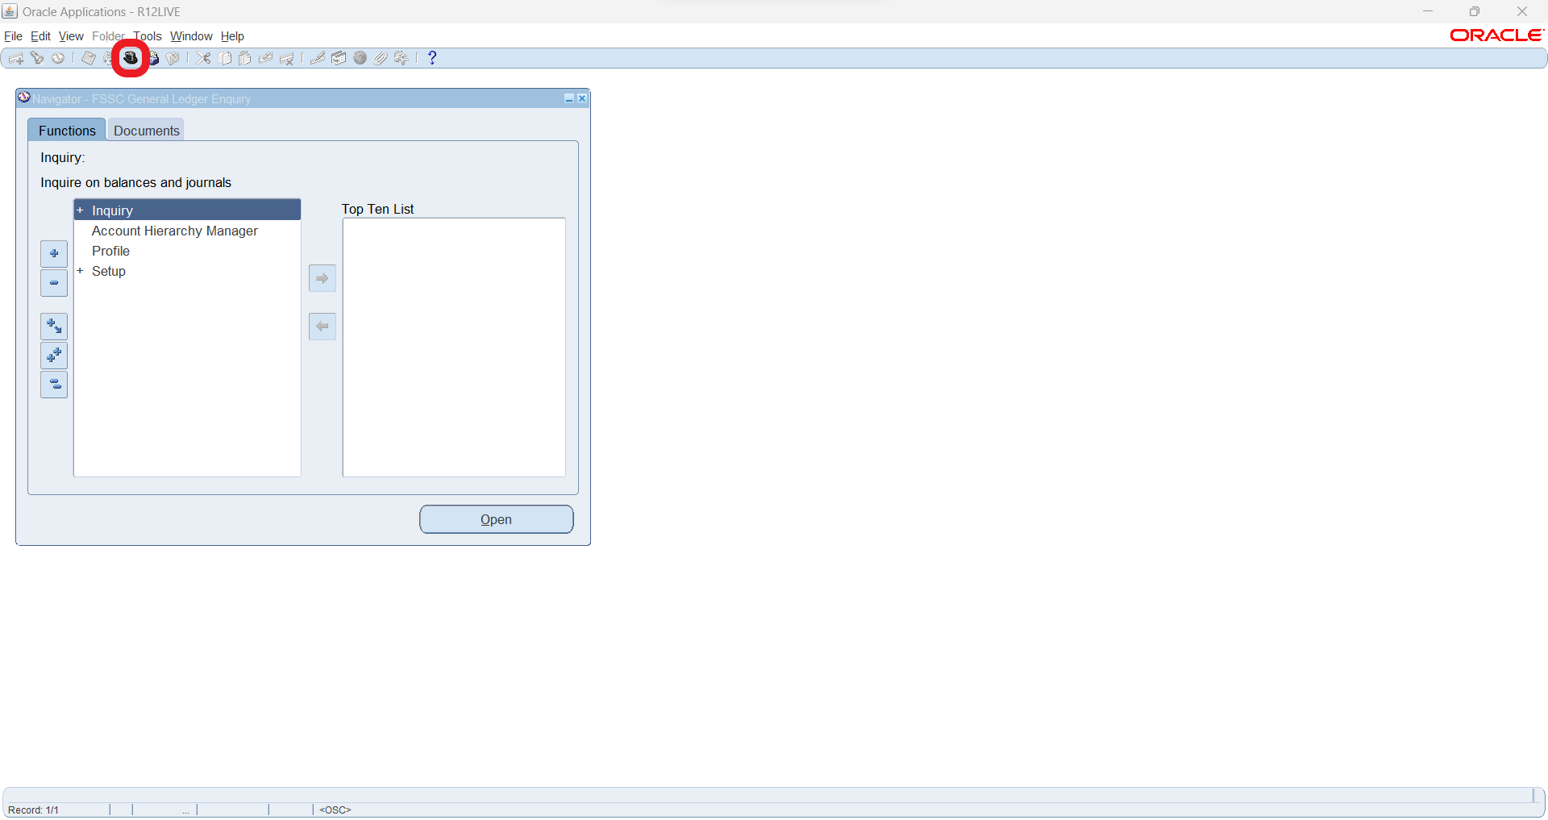
- Select SplashBI from the menu is click OK
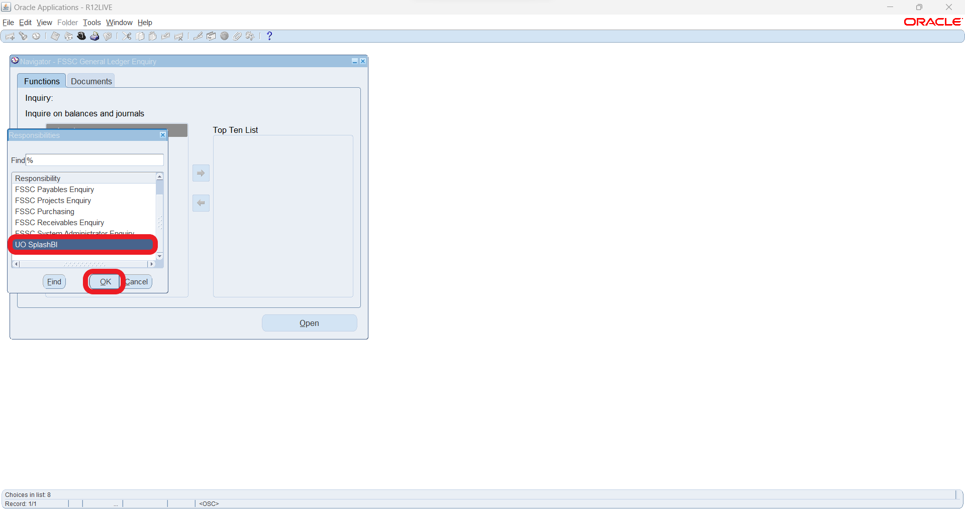
- The SplashBI page should launch as normal
