SplashBI - Distribution key features

SplashBI has many useful features for distributing reports, including:
- Password protection
- Failure notifications
- Sending to multiple recipients
- Choice of output format
This functionality can also be combined with scheduling.

Distribution in SplashBI

- Once logged into Splash, navigate to Reports
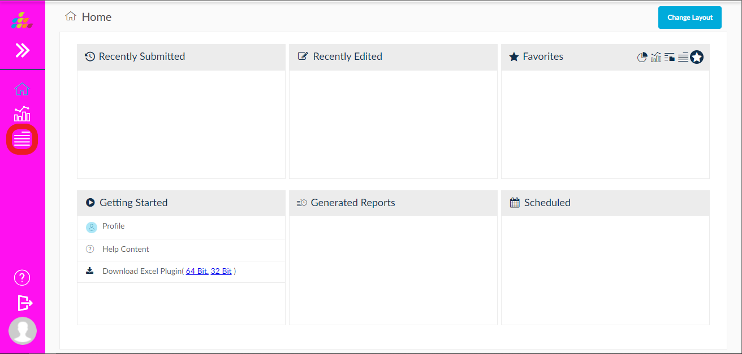

- Locate the report to be distributed, and click the run icon

- Enter your parameters as required, then select Distribution
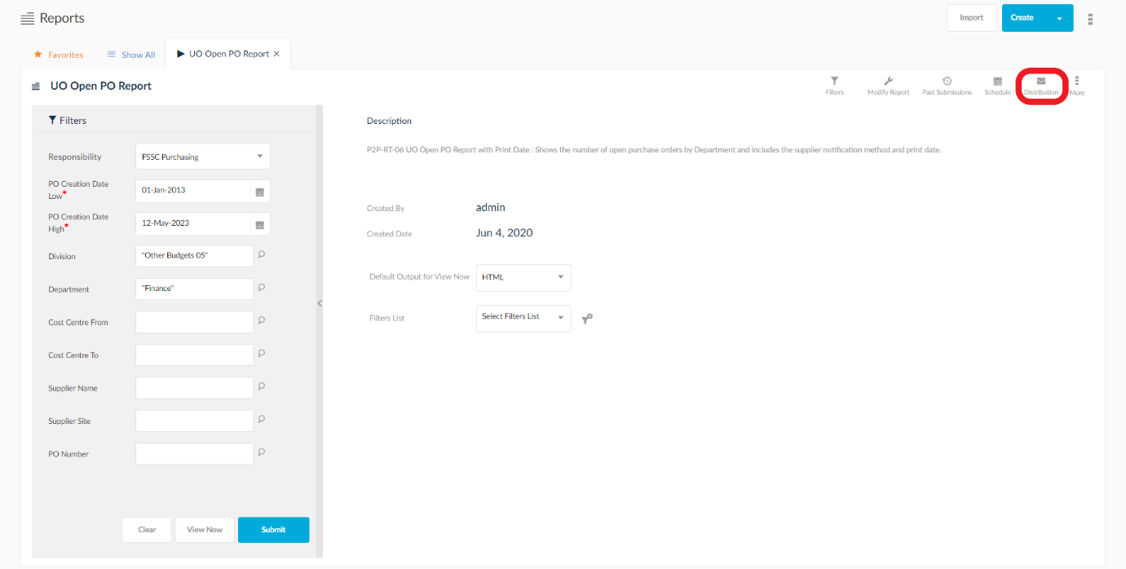

- The Distribution screen provides many options for sending your report by email.
Password Protection: Enter a password to lock any selected outputs. Please note that CSV files cannot be password protected.
Notification On: Enter an email address to receive notification of failure to send, and/or whether the report errored or terminated.
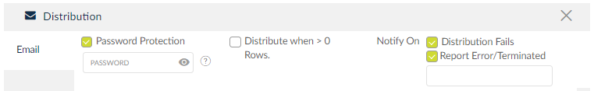
Email: Enter an email address (or multiple addresses each separated by only a comma) of the report’s recipients. Do not use the Users or User Groups drop down menus.
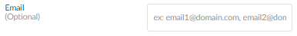
Outputs: Select which output formats will be attached to the email. Note that not selecting at least one output will result in a simple notification email being delivered.

- To confirm the distribution settings and submission of the report, click Save & Submit
