Clearing browser cache (Windows)

How to clear browser cache in Edge, Chrome and Firefox
Clearing browser cache can aid in improving the reliability of SplashBI.
The three browsers listed here have similar steps and use a common shortcut (CTRL + SHIFT + DEL).
This shortcut will skip straight to step 4 for all browsers.
It is advised that only Cached Images and Files are cleared.

Edge

- Navigate to the 3 dots in the top right corner

- Select Settings
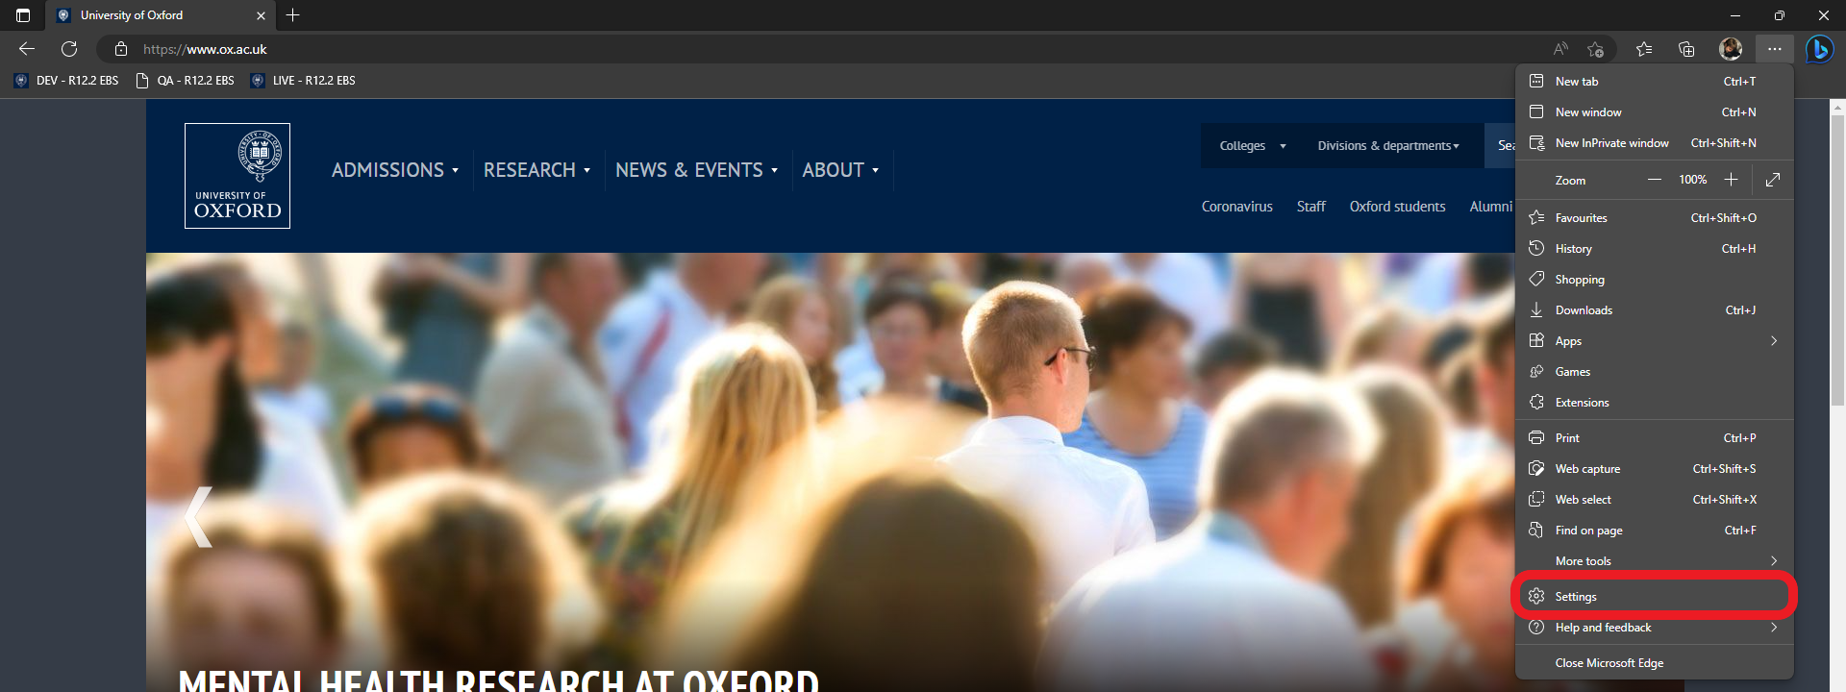

- Select Privacy, search, and services, then under Clear browsing data, click Choose what to clear
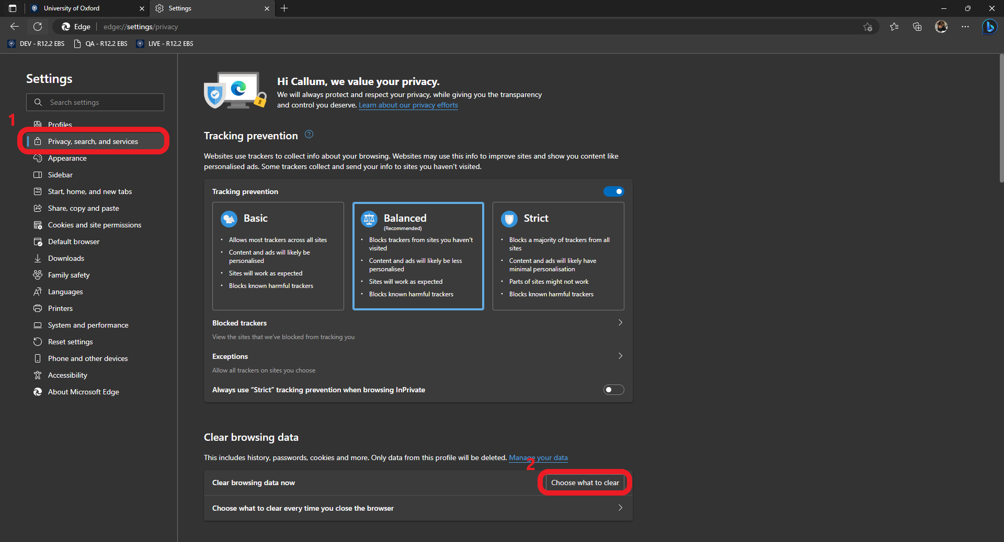

- Choose the time range. Selecting All time from the drop-down will ensure that all cache is cleared.
It should be noted that only the Cached images and files should be selected.
Select Clear now to clear cache.
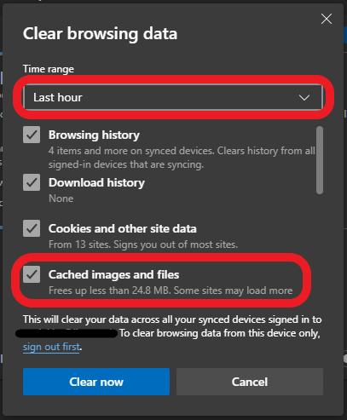

Chrome

- Navigate to the 3 dots in the top right corner

- Select Settings
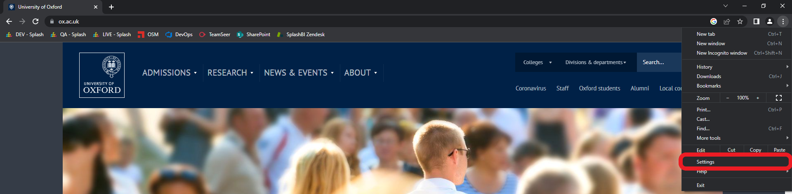

- Select Privacy and security, then click Clear browsing data
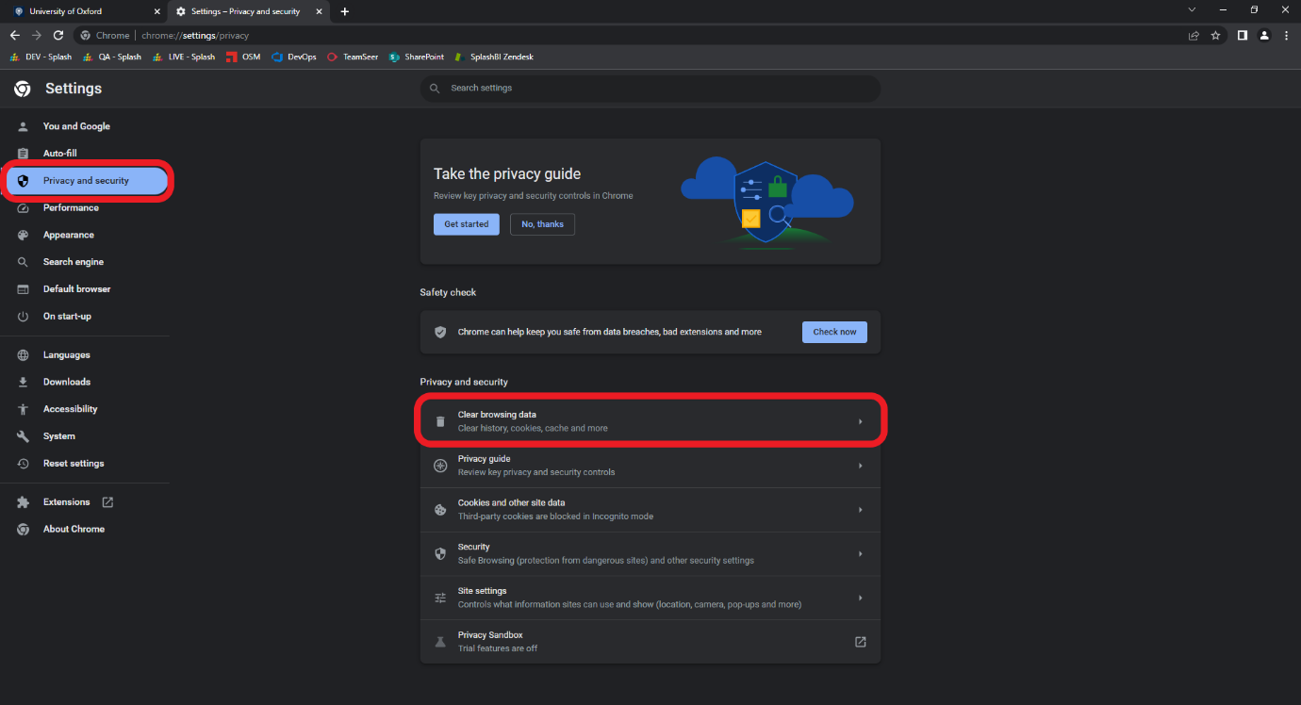

- The Time range will default to All time.
Only Cached images and files needs to be selected.
Click Clear data to confirm.
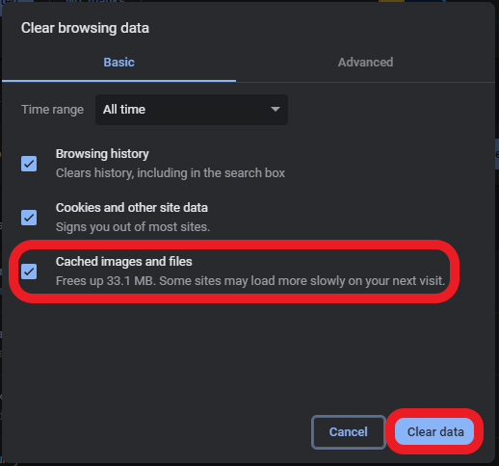

Firefox

- Navigate to the 3 bars in the top right corner

- Select Settings
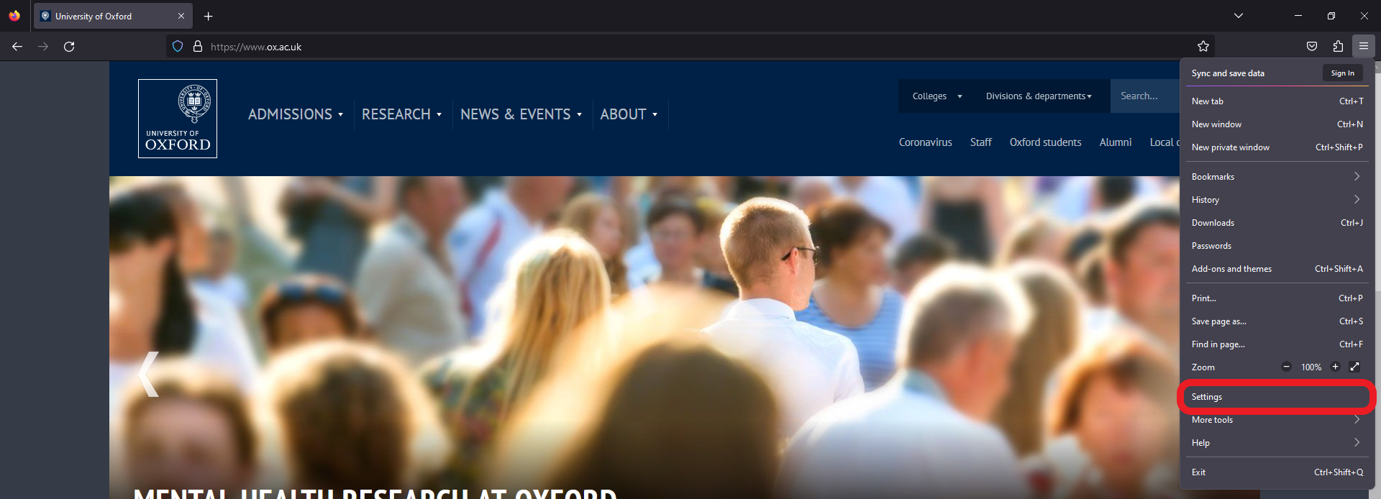

- Select Privacy and security, scroll down to Cookies and Site Data.
Select Clear Data.
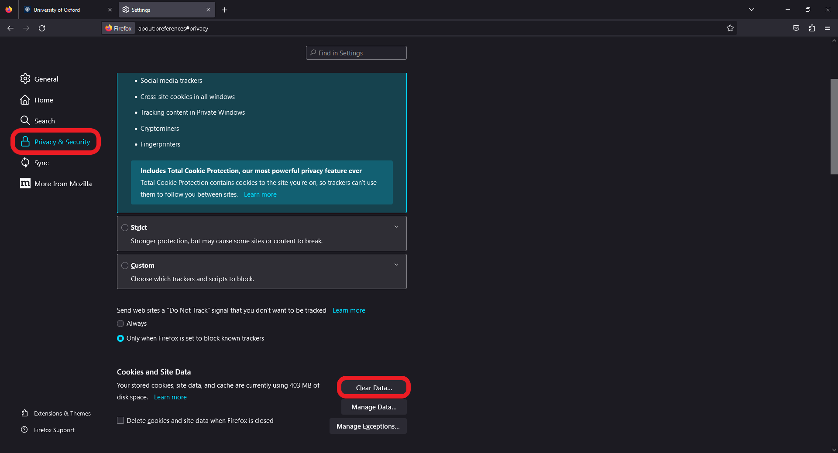

- Select only Cached Web Content, then click Clear
