Guide for VeriFone Payment Devices

- Which model do I have?
- General
- Transactions
- Reporting
- Device Security
- Common issues
- Installing a new payment device
- Contacts

Which model do I have?

Please check on the device, it should be marked on the top right
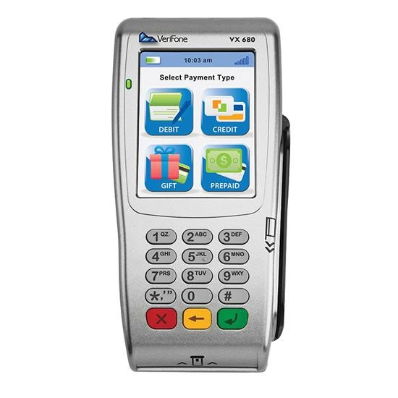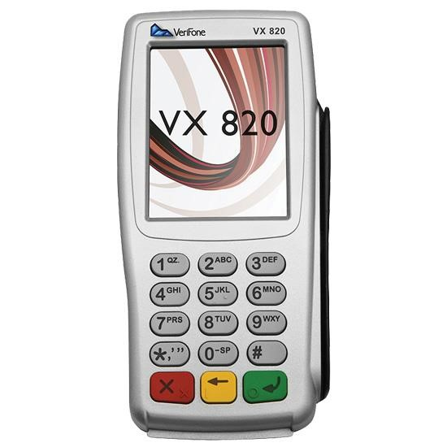

VX680 VX820

General

Start up and Close Down

Power on - either press the green button or connect to a power supply, such as a cradle. The device will display a message asking to start communication. Either press the green button or the Yes button on the screen.

When requested, enter the USER ID and PIN number for the device. This will take you to the main menu.

Power off – hold the Red cancel button, the screen will flash and after about 6 seconds it will power down. This will not work while the device is connected to a power supply, such as in a cradle.

Transactions

See the Verifone Quick Reference Guide for your device (available at the end of this document) regarding information on entering transactions.

Please note:

- Mail and Telephone (MOTO) orders and refunds should be processed using the “Cardholder not Present” menu option. This will take you to a menu for Mail order and Telephone order transactions and refunds.

- If the transaction or refund is above the ‘standard’ User limit, it will need to be processed using the Supervisor ID.

- Refunds will require the PIN number allocated to your device for authorisation. Refunds do not require the customer’s PIN or CVV number.

Reporting

The Verifone devices do not require an end of day Z report to total and ‘bank’ transactions, as they are processed on receipt. If you require a Z total or transaction report for end of day checks on totals and receipts, the reports can be found under:

- key 1 Menu
- key 2 Trx Managment
- key 1 Reports

The Z Report will list the end of day totals. The transaction report will show the transaction numbers for the day.

Device Security

- All devices have a Standard User ID, and a Supervisor User ID with higher refund limits. Please contact the Cashiers Office for information regarding your Supervisor ID and PIN if required.

- Please log out of the Supervisor ID once you have finished using it.

- It is good practice to log off at the end of each day.

- If not being used for a while, either power off the device or log off using menu option 3. The device should be stored securely when unattended, to avoid the risk of someone tampering with it.

- When logging in with a different ID (i.e. as Supervisor, rather than Standard user) the machine will ask for confirmation for the new log in, and require to enter a Manager PIN (which is 5555).

Common issues

Forgotten User Id or User ID not working

Please contact the Cashiers office (contact details below).

You need to change the User ID due to staff leaving or security concern

Please contact the Cashiers office (contact details below).
Please DO NOT use the device menu options to reset the User ID.

Any configuration changes will only be uploaded to your device when it is logged off and then on again.

The Device is not switching on

The battery is probably flat; please connect the base or cable to charge the device.
If after a little while there is no improvement, please contact Verifone (please see contact details below).

Please note that the GPRS devices are recharged using the cable provided, not a cradle.

Tamper Mode Enabled message

This message may be displayed if you drop or knock the device. It suspects someone is trying to break into the device and has locked itself down. In this case the device must be returned to the supplier for resetting; please contact the cashiers department.

Unable to connect to network on VX820

Please check that the network cable is plugged in correctly at both ends; if the cable is fitted properly but you are still unable to connect, please contact your local IT Support Staff.

Unable to connect to network on VX680 wireless

Please move to find a stronger signal; if you are unsuccessful, please contact your local IT Support Staff.

Multiple network addresses showing

This is due to device being connected in Bridged mode; please contact your local IT Support Staff to help change the connection mode from bridged to Routed mode.

Alternatively you can find instructions to perform this change at the following link: Changing VX680 connection mode guide

Unable to connect to connect to network on VX680 GPRS

There is no mobile phone signal. Please the following steps in this order:
- move to another location with stronger signal
- switch the device off and on to see if a better signal supplier is picked up
- check on the internet the mobile phone supplier's site for any local GPRS issues.
If none of the above resolved the issue, please contact the Verifone support desk (contact details below).

Transaction exceeds limit

The default device configuration is set for a specific transaction limit. If you need to process a transaction with a higher limit, please contact your manager in order to use their login (which has higher limits), or alternatively contact the Cashiers office (contact details below).

Incorrect Merchant ID (MID) or similar account issues

First check that your MID is correct; then please contact the Cashiers Office (contact details below).

There is paper in the device (VX 680), but there is no receipt coming out

The paper roll might be too thick for the device, causing it to jam. Please remove a number of paper sheets, then reinsert the roll and try again.

The Terminal stops working

Please contact the Cashiers Office (contact details below) for instructions on getting a replacement device.

You need additional information on a transaction or group of transactions

Please contact the Cashiers Office (contact details below); they can review transactions via the Webcomm application.

Any other ‘How to’ questions

Please contact the Cashiers Office or read the device Quick reference guide (QRG):

VX 680 Bluetooth
VX 680 GPRS
VX 680 Wireless
VX 820

Installing a new payment device

College/Department (not UAS)

If you are not part of UAS (University Administration and Services), please contact the Cashiers Office (contact details below) and also your local IT Support Staff.

UAS (University Administration and Services)

If you are a member of UAS (University Administration and Services), please contact your local IT Support Staff (help@it.ox.ac.uk or 01865 6 12345) to request that the device is registered on the network; you will need to provide the MAC (Media Access Control) address.

Where to find the MAC address
Please look on the back of the device (number 4 in the picture below)
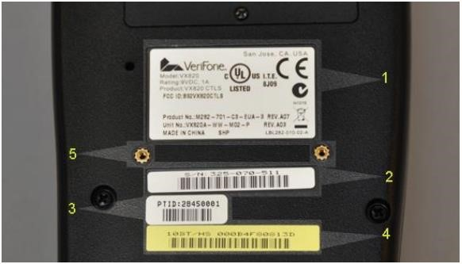

1. General Product: Contains the device product number, model and power requirements
- S/N: Unique device serial number
- PTID: Unique Physical Terminal Identifier
- MAC Address: Unique network identifier
- Space Pole Connector

VX 680 Bluetooth
Once the device is registered on the network, you will be provided with an IP address, Subnet Mask, and Gateway; please enter the details required on the payment device as follows:
- Restart terminal by holding cancel button
- Power back up with green button
- Click setup instead of entering to start communication
- PIN is 2580
- Key 1 for Network Settings
- Key 3 for Terminal
- Key 1 or Terminal IP
- Push and hold clear to clear address
- Enter 0.0.0.0 (to type a . please press the * button)
- Then do same for subnet mask
- Then do same for the IP gateway
- Push cancel button 3 times to go to start screen.
- Then follow DHCP below.

- Restart device – pull power from base to reset base. Then red button to close down handset.
- Using a computer on the same network, logon to base unit when powered up using IP address (click on Start > search for Run > click on Run > enter the details provided by your IT Support Staff > click OK).
- Go to set up (just under Verifone logo) – see screenshot below

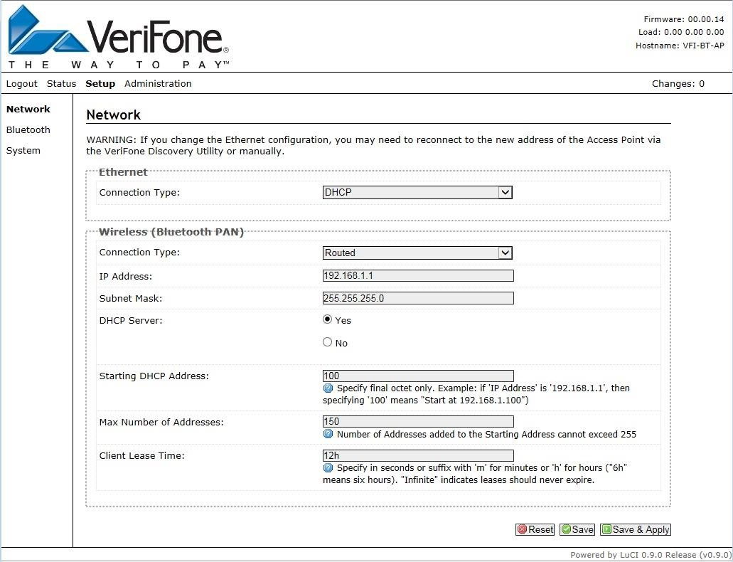

- your device will then need to be switched from Bridged to Routed Mode; please follow steps below:

Change wireless (Bluetooth) PAN connection type from Bridged to Routed.

- Put in IP address: 192.168.1.1
- Put in subnet mask: 255.255.225.0
- Save and apply
- It will sit on this screen for a while.
- When it goes to a blank screen, logout
- You can log in again if you wish to recheck set up

Test device
If device routed sys info report it will have IP address of 192.168.1.*

VX 680 GPRS
This model should work out of the box. The APN (Access Point Name) is pre-configured for the VX 680 GPRS terminal by Verifone, prior to dispatch.

VX 820 DUET
Once the device is registered on the network, you will be provided with an IP address, Subnet Mask, and Gateway; please enter the details required on the payment device as follows:
- Restart terminal by holding cancel button
- Power back up with green button
- Click setup instead of entering to start communication
- PIN is 2580
- Key 1 for Network Settings
- Key 3 for Terminal
- Key 1 or Terminal IP
- Push and hold clear to clear address
- Enter the IP provided by your local IT Support Staff (to type a . please press the * button)
- Then do same for subnet mask
- Then do same for the IP gateway
- Push cancel button 3 times to go to start screen.

Contacts

- Verifone support desk: 08444 828 222 or ocius.helpdesk@verifone.com
Please note that they might request Merchants ID (MID) for the device as identification.

- Cashiers Office: 16129 or cashiers@admin.ox.ac.uk

