

Oxford University

## New legal entity approval and implementation process

Working DRAFT

|  |  |  |  |
| --- | --- | --- | --- |
|  | **Name** | **Job title** | **Date** |
| **Prepared by** | Jane Bardell | Project Manager | 28/6/2018 |
| **Reviewed by** | Ben Heath | Financial Controller |  |
|  | Sally Vine | Head of Risk and Assurance |  |
|  | Carolyn McKee | Head of Legal Services |  |
| **Process owner / Approved by** | General Purpose Council |  |  |
| **Document location** |  | **File version** | 1 |

New legal entity approval and implementation process

# Contents

## Introduction Page Nos

When to incorporate a legal entity (e.g. subsidiary or Joint Venture) **1**

## Process for approval of a new entity 5

* 1. Process description
  2. Process Flow diagram

## Roles and Responsibilities 9

# Introduction

## Approval of a proposal and when to open a new legal entity[1]

The University is often the recipient of offers of funding for projects and research from a variety of organisations in the UK and overseas, managing these activities and funding via a separate legal entity is sometimes appropriate. Tax and legal requirements may also occasionally drive the need for a new separate legal entity.

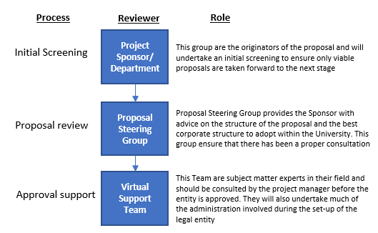There are three stages to establishing a new legal entity;

**Initial Screening**

Sponsors should only take forward proposals for a new a legal entity if they can clearly demonstrate that;

1. The proposal is fully funded and there is no additional financial commitment required from the University
2. The activity is in support of the University’s main purpose of furthering education and research
3. All conflicts of interest have been declared and the project will not result in personal gain
4. The proposer is confident of the success of the activity and can clearly demonstrate grounds for this confidence

If a proposal meets these criteria the Sponsor is responsible for managing the process to assess its suitability for a new legal entity

**Proposal Review**

This is undertaken by a Proposal Steering Group comprising representatives from Legal services, Company Secretariat and Finance who will be consulted and will be key to supporting the Project Sponsor and advising on what options are available after considering factors such as;

* Nature of activity to be undertaken by the entity and whether it is part of the University’s main purpose
* The proposed owner of the entity (i.e. Chancellors Masters and Scholars or jointly held with others)
* Length of operation of the activity, the jurisdiction and the value of assets involved
* Status of existing companies owned by the University in similar areas which could be used
* Tax environment and the possibility of a tax liability
* Regulatory restrictions which require a specialist structure
* Strategic and operational risks including financial and reputational risk

The proposal steering group will advise the Registrar and GPC on the suitability of the entity for incorporation.

**Approval support**

Should the need for a new legal entity appear to be the most appropriate way to proceed, advice will be given on which type of legal entity should be incorporated.

This virtual team has a range of expertise valuable in ensuring the best outcome for the University and the Project. This team will make plans to be put in place post incorporation and will inform GPC of any issues likely to arise from the new entity

The Project Sponsor will prepare a paper to be presented to GPC for approval. Once incorporated the entity will form part of the portfolio of subsidiaries subject to GPC reporting and scrutiny

## Process for project approval

## Process description

### Proposal phase

* 1. When the University is considering an opportunity which involves funding from a third party, the Financial Regulations[2] require the opportunity to be subject to review by the Research Services Team and/or the Development Office for its suitability for University participation. This review process can be found at:
     + <https://researchsupport.admin.ox.ac.uk/applying/overview>
     + <https://researchsupport.admin.ox.ac.uk/awards/process>
  2. At this early stage of the project it is also important that any conflicts of interest are declared in accordance with the Conflicts of Interest policy and procedure: <https://researchsupport.admin.ox.ac.uk/governance/integrity/conflict/policy>

All members of staff are responsible for identifying and declaring actual or perceived conflicts, and their Head of Department will generally be responsible for considering conflicts and ensuring these are adequately managed; they may refer issues to the Conflict of Interest Committee for advice.

* 1. When the proposal has cleared this funding and conflicts of interest review and a new legal entity is being considered for use or involvement with the University the Project Sponsor should screen the proposal against the key criteria before deciding to proceed ensuring that;

1. The proposal is fully funded and there is no additional financial commitment required from the University
2. The activity is in support of the University’s main purpose of furthering education and research
3. All conflicts of interest have been declared and the project will not result in personal gain
4. The proposer is confident of the success of the activity and can clearly demonstrate grounds for this confidence
   1. If the proposal satisfies these criteria the sponsor should contact the Proposal Steering Group (PSG) which comprises Legal Services, the Financial Controller and the Company Secretariat (see attached contacts list) to discuss the opportunity and explore if a new legal entity is an appropriate. This team will assign the proposal with a case reference number so that its progress through the approval process can be monitored and reported.
   2. The PSG will give initial advice on the most appropriate form of legal entity to be established (i.e. Ltd, LLP etc. and will consult with the Head of Tax to ensure the proposal is in line with the University tax strategy, does not give rise to any tax liabilities and is tax efficient
   3. Once the PSG has feedback their advice and are supportive of the need for a new legal entity the Project Sponsor should prepare an initial proposal paper (template attached in Appendix I) to provide more information on the proposal. This should be sent to;
      * The Steering Group
      * Planning and Council Secretariat and
      * Virtual Support Team

If the Steering Group do not believe a new legal entity is necessary they will advise the project sponsor on how the project can be taken forward using existing University structures.

* 1. The Virtual Support Team (VST) are subject matter experts in support services around the University and will collaborate with the Project Sponsor, and each other, to provide guidance on the detailed legal and administration issues to consider in forming the entity. As a rule the team comprises
     + - Financial Reporting
       - HR services
       - Treasury management
       - Tax
       - Company Secretary
       - Legal services
       - Risk Assurance and management
       - Insurance
       - Others as required e.g. Estates, Research services
  2. The VST will use their experience and expertise to consider the proposal and will ensure that plans can be put in place for registration or incorporation. As the VST will be the group who will ultimately support the legal entity, this is a vital stage in ensuring the entity is correctly established.
  3. Once VST has been consulted and more detail prepared around the proposal paper, a consent schedule should be signed by members of the support team for the proposal to proceed to General Purpose Council (GPC) for approval. The VST or PSG may flag any issues or concerns at this stage to GPC which may include modifications and/or conditions to any approval.
  4. Planning and Council Secretariat will feedback on the Proposal and on the appropriate route for approval of the entity. Overseas entities or Joint Ventures may also require approval from Council. It is the Project Sponsor’s responsibility to ensure that the relevant meetings for approval are identified and submission deadlines communicated to the team for the final paper preparation.

### Approval phase

* 1. Once feedback on the initial paper and support for the Proposal has been received, the paper should be revised into final form by the Project Sponsor and be submitted to the Head of Assurance and Risk Management for review. This risk review should form part of the final paper to GPC
  2. The final proposal paper should then be presented to the Proposal Steering Group and Planning and Council Secretariat for final review and then submitted to GPC or Council for consideration and approval.

### Implementation – set up phase

* 1. After approval has been given by GPC or Council, the PSG will arrange for incorporation of the entity and inform the VST once this is complete.
  2. The VST will work to set up the necessary support structures based on the plans put forward in the Proposal Paper
  3. The work to be undertaken in setting up a legal entity will include (but is not limited to) answering the main checklist of items included in the “Subsidiary in a box” paper.

Throughout this process there are inevitable iterations whilst information is refined and changed to reflect new information. Not all steps will happen sequentially but, at the point of presenting the Proposal to GPC, all relevant team members should have been consulted and given their consent to proceed.

## Process flow diagram

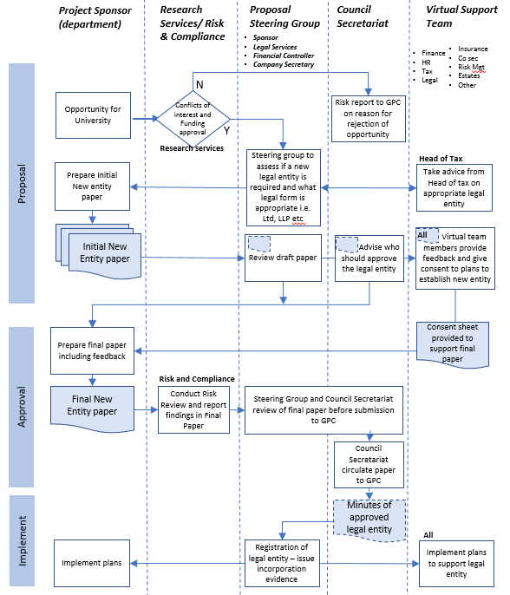

## Roles and Responsibilities

**Project Sponsor and Department/Division**

This group are the originators of the proposal and are the champions of the opportunity within the University. Usually this group have identified a funding opportunity associated with research and development already underway within their Department. This group will be responsible for implementing and managing the output of any external relationships resulting from the opportunity.

**Proposal Steering Group (PSG)**

The Proposal Steering Group provides the Sponsor with advice on the structure of the proposal and the best approach to pursing the opportunity within the University. This group ensure that there has been a proper consultation of all relevant teams and that the risks have been identified and considered before the proposal appears on the agenda for GPC. Some members of the Steering Group may also be part of the support team.

**The Virtual Support Team (VST)**

This Team are subject matter experts in their field and should be consulted by the project manager on the best way to implement the proposal. In addition to advising on any strategic issues around the registration of the entity they will also undertake much of the administration involved during the set-up of the legal entity such as recruiting staff, opening bank accounts and setting up payroll and expenses processes.

|  |  |  |
| --- | --- | --- |
| **Stakeholders** | **Roles and Responsibilities** | **Contact** |
| Project Sponsor | The representative from a Department / Division or research group who has identified the opportunity and is championing it through the University. |  |
| Legal Services | The Legal Services Office supports academic and administrative departments and divisions by providing legal advice, both directly through its own professional staff and, if required, by engaging and managing external support. This team also provides or sources legal support for the University's wholly owned legal entities | Carolyn McKee |
| Company secretary | Provides Company Secretarial services within the University including incorporation and administration of legal entities. This includes board meetings and compliance with the Companies Act. | Sophie Pryor - Company Secretary  Helen Wailling – assistant Company Secretary |
| Financial Reporting - subsidiaries | Responsible for all aspects of Finance in relation to University entities including reporting, budgeting & forecasting. This group also access all accounting services such as payroll and Accounts Payable on behalf of subsidiaries. | Ben Heath – Financial Controller  Kathryn Marshall – Subsidiaries team  Rosie Tullett – Subsidiaries team |
| Taxation | The tax team provide advice on all aspects of tax including Employment taxes, Corporation taxes, VAT and will ensure the right advice is accessed in overseas jurisdictions. | Sally McKinlay  Head of Tax |
| Treasury | The treasury team are responsible for all banking arrangements and relationships within the University and all currency and treasury management. | Jan Smith Treasury and cashiers manager |
| HR | Responsible for all aspects of staff management processes including recruitment, retention, reward and pastoral care of University staff. | Sarah Thonemann  Head of HR Policy |
| Insurance | The [Insurance Team](http://www.admin.ox.ac.uk/finance/insurance/contacts/) arranges cover for the University's property, travel, motor vehicles and legal liabilities such as employers' liability and professional indemnity. Certain specific 'ad-hoc' covers are also arranged. | Lyndie Hayes  Insurance manager |
| Assurance, Risk management and Compliance | Responsible for the risk management framework – this team also support the University’s Audit and Scrutiny Committee and organise Internal audit and risk register reporting | Sally Vine  Head of Assurance and Risk Management |
| Others as applicable | As required by the nature of the organisation |  |

## **APPENDIX I** Draft Proposal for Legal Entity

|  |  |  |  |
| --- | --- | --- | --- |
| Project Manager Name |  | Department/division |  |
| Proposed date of commencement of activity |  | Address of incorporation including country |  |
| Ownership %  e.g. 100%, > 100% , JV  including names |  | Name of 3rd party (ies) involved in Legal Entity if any |  |
| Has the funding application been approved by Research services? |  | Has the proposal cleared the “conflicts of interest” review? |  |
| What committee approval route is Proposed UK – GPC, Overseas Council approval required (?) | | | |
|  | | | |

## Purpose

|  |
| --- |
| What is the purpose of the proposed Legal Entity?  Please include main activities of the Legal Entity i.e. research, trading, investment. |
|  |
| Why is a legal entity required and what type of entity is proposed and why?  Please describe what type of legal entity and how it will be structured e.g. Ltd by share or guarantee |
|  |
| What alternatives have been considered? |
|  |

## Activity

|  |  |  |  |  |  |
| --- | --- | --- | --- | --- | --- |
| What is the expected level of activity? (e.g. annual income levels, number of employees, types of assets, frequency of spend) | | | | | |
| Annual Operating expenditure |  | Approximate annual income |  | Approximate set up Capital expenditure |  |
| Number of employees |  | Overseas annual expenditure |  |  |  |

|  |  |
| --- | --- |
| Please provide outline benefits of the proposal or attach the business case or grant application for the venture | |
|  | |
| What are the proposed sources of funding ?  Government / Private Equity / Donor / Grant etc | Who will provide the funding?  Welcome trust / UK Govt/ EU grant/ US grant etc |
|  |  |

## Risk review

|  |  |
| --- | --- |
| Please provide a high level summary of the risks and how they will be mitigated for the venture | |
| Risks | Mitigants |
|  |  |

## Governance

|  |  |
| --- | --- |
| Who are the proposed directors for the Legal Entity and why?  CEO, Finance, Legal, Co. Secretary | Have they completed Conflicts of interest checks? |
|  |  |
| What support services are required?  Finance, IT, HR, audit, insurance, Risk Management, Legal Services, Company Secretarial | |
|  | |
| What governance arrangements will be put in place?  (e.g. Reporting, meeting frequency and attendance, roles and responsibilities) | |
|  | |

# Appendix II - Consent for submission to GPC

|  |  |  |  |  |
| --- | --- | --- | --- | --- |
| **Support Department** |  | | **Signature** |  |
| **Consent to proceed given?** | Yes |  | **Name** |  |
| No |  | **Date** |  |
| **Additional comments on the proposal including concerns or outstanding issues not covered in the proposal report** | | | | |
|  | | | | |

|  |  |  |  |  |
| --- | --- | --- | --- | --- |
| **Support Department** |  | | **Signature** |  |
| **Consent to proceed given?** | Yes |  | **Name** |  |
| No |  | **Date** |  |
| **Additional comments on the proposal including concerns or outstanding issues not covered in the proposal report** | | | | |
|  | | | | |

|  |  |  |  |  |
| --- | --- | --- | --- | --- |
| **Support Department** |  | | **Signature** |  |
| **Consent to proceed given?** | Yes |  | **Name** |  |
| No |  | **Date** |  |
| **Additional comments on the proposal including concerns or outstanding issues not covered in the proposal report** | | | | |
|  | | | | |

1. **Legal entity** – this term is used to cover all vehicles used to represent the University, this includes but is not limited to; companies (wholly or partly owned), Joint Ventures. These entities may take several legal forms in the UK e.g. Ltd or LLP. Overseas there are many forms of legal entity depending on the country of incorporation.
2. Financial Regulations Part 2 sections 2.3 and 2.4.