Departmental Project Amendment Form (DPF2) instructions
The DPF2 form can be used to make any one or combination of five types of amendment to an existing departmental or studentship project. The changes that can be made using this form are as follows:
- Date changes (project level, top or sub-tasks or both)
- Adding new tasks
- Budget uplifts (e.g. additional budget being added to a project overall)
- Budget virement (both across tasks and between budget headings)
- Budget reduction (e.g. budget being removed from a project overall)
Steps for preparing and submitting a change request
- On the front page of the form (worksheet entitled ‘FRONT PAGE’), please complete all relevant fields, and indicate which type of project amendments you are wanting to make by ticking in the relevant box(es):
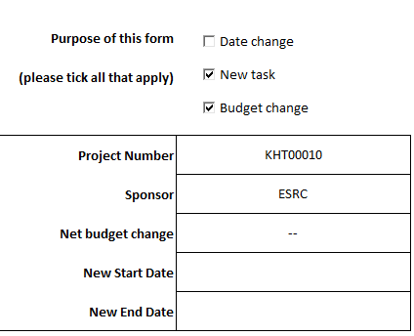
Please note that the ‘net budget change’ field will be highlighted in red if the value entered does not match the sum of all changes listed in the ‘DETAILED CHANGES’ worksheet (covered in point 2). This field should always have a value entered, either 0 for budget movements within the existing budget on a project, or the value of any budget uplift/reduction to the project as a whole.
Please use the notes section to highlight any information that you believe would be relevant to research accounts in connection with your intended changes, e.g. burdening rates to be applied to any new tasks, funder/donor approval for an uplift to the budget on the project, location of funds for any uplifts if received into a departmental GL, etc.
- Go to the ‘DETAILED CHANGES’ worksheet. Each row on this spreadsheet represents changes to a particular budget resource for a sub task. For a given sub task, start by selecting what the desired change is, choosing from the following:

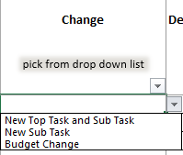

Explanatory notes on each of the three ‘change’ options:

- New Top Task and Sub Task – this option should be selected if the creation of a new top task and sub task is required, and normally involves an associated budget change. In column L specify the budget resource you wish to assign to the new subtask. In column M type in the required budget amount.

- New Sub Task – this option should be selected if a new sub task is to be added under an existing top task, and normally involves a budget change

- Budget Change – this option should be selected if a change of budgets is required on existing sub tasks within a project

Please note: due to system limits, for any new top tasks and sub tasks, the maximum length of text string that can be entered is 20 characters. Task descriptions are limited to a maximum length of 250 characters.

Once an option has been selected, enter the task information (i.e. top task and sub task numbers), along with the desired changes (e.g. date changes, budget changes, etc as required), completing all relevant fields for as many sub tasks as necessary.

For any budget changes – the figures entered in the ‘Budget Change’ column should represent the movement of budget from/to for a given resource on a given task, be it a proportion of the total budget for a resource/task or otherwise, rather than entering the overall revised total budget.
Any mandatory fields that have not been completed that are expected to be based upon the indicated change type, will be highlighted in red, as in the below example:
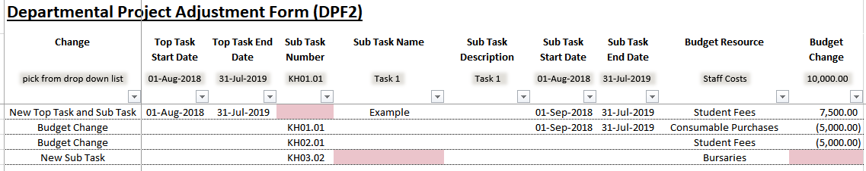
Requisition approver positions: Please note that if different requisition approver positions are required for different sub tasks, ensure that they are under different top tasks, as the requisition approver functionality is only effective at top task level.
- Note on externally funded projects: when submitting requests for any budget uplifts or reductions (in the context of funds being either added to or removed from a project) for externally-funded projects, an award letter or other explicit written confirmation from the funder indicating that they approve/authorise the uplift/reduction must accompany the request. Emails in which departments confirm that they have spoken to the funder (e.g. on the telephone, etc) will not suffice.

- Approvals: Returning to the front page, please indicate who the form has been completed by, and what date the form was completed on. Please also ensure that the ‘Approved by’ field is completed by either the Head of Unit or the relevant person to whom their authority is delegated within your department/division, consistent with the policy outlined in the University’s Financial Regulations (see point 1.5 (g) and (h) - https://finance.web.ox.ac.uk/financial-regulations):

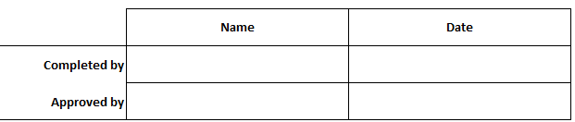

In addition to these fields being completed, please also ensure that the involvement of the approver is evidenced in the submission of the set up request to Research Accounts. This could take the form of one of the following options:

- The approver forwards the request directly to Research Accounts, or;
- The approver is copied in on the email submission to Research Accounts, or;
- An email trail is either appended or attached to the request in which the approver indicates confirmation of their approval.
Once the above steps have been completed, the spreadsheet should be sent to Research Accounts at dept.projects@admin.ox.ac.uk (non-studentship projects) or studentships-ra@admin.ox.ac.uk (studentship projects) for processing.

