Departmental Project Set Up Form (DPF1) instructions

Please note: this form should be used for both studentships and departmental projects set up requests.

- On the first worksheet (titled ‘FRONT PAGE’), please complete all of the blank fields where applicable.

  - For the ‘Project Type’ field, please ensure that the correct project type is selected that is relevant to the type of activity that you wish to set up, from the drop down menu, so that the correct configuration is used when the project is set up by Research Accounts:
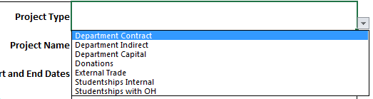
The following table provides a brief guide as to what each project type might be suitable for:
Project Type | Internally/externally funded | Description | Additional Notes
Studentships with OH | Externally funded | Used for externally funded studentships | Requires signed copies of award letters/contracts, etc.
Studentships Internal | Internally funded | Can be used for internally/departmentally funded studentships
External Trade | Externally funded | Can be used for external trading activity that could be considered a project (e.g. specific purpose, timeframe, budget, etc) | Requires approval from the Subsidiaries team within Financial Reporting before set up
Donations | Externally funded | Can be used for restricted donations/funds gifted for a specific purpose | Requires signed copies of deeds of gift, etc. Approval from Financial Reporting is required before set up. Receipt of funds handled by Gift Registry. Budget is set based on cash received
Department Capital | Internally funded | Used for activities that will have capitalisable costs, including departmental refurbishments, capital works, etc | Requires approval and capital/revenue split decision from the Fixed Assets Team. If external funding is to be received for this activity, the department will be responsible for billing, and notifying both the Fixed Assets and the departmental projects teams when funds are received
Department Indirect | Internally funded | Can be used for any non-funded activities that are not capitalisable and are not related to studentship activity, e.g. academic/PI start up funds
Department Contract | Externally funded | Can be used for a wide range of externally funded non-research and non-trading projects activity e.g. visiting academic awards to undertake specific work, etc | Signed copies of contracts/award letters are required for set up

Please note: it is not possible to have a combination of internal and external funding on a single project.
Further guidance on selecting the correct project type can be obtained by reading the relevant sections of the departmental projects website at https://finance.web.ox.ac.uk/departmental-projects-2 or by contacting the departmental projects team at dept.projects@admin.ox.ac.uk.
Project name field length restriction: For the project name field, please note that Oracle is restricted to a maximum of 30 characters.
  - If the currency for the project is GBP, please enter 1 as the exchange rate, and then enter the total budget to be allocated in the ‘Total budget’ field. If the currency is anything other than GBP, please use the drop down menu to select the correct currency code, and enter the exchange rate as per the relevant project documentation:

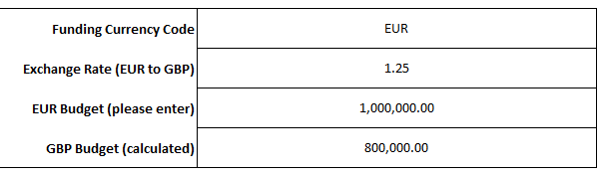

The exchange rate must be entered based on the foreign currency to GBP rate, e.g. if the rate is 1.25 EUR to 1 GBP, then the value that should be entered is 1.25 (i.e. in the same format as the X5 rate is published). Please note that upon initially entering the budget, the ‘GBP budget (calculated)’ field will turn red, to indicate that not all of the budget has been assigned to tasks. This will turn white (as above) once all available budget has been assigned to tasks on the ‘DETAILS’ worksheet (see section 2 of this guide).

  - For all of the project types listed in the table under 1.a, it is mandatory to complete the tax treatment section. Please also complete the customer information section (if externally funded) fields. If there is any uncertainty regarding the correct VAT treatment, please be sure to obtain the correct treatment from VAT team by contacting them at vatenquiries@admin.ox.ac.uk, and include a copy of this correspondence with the project set up request.
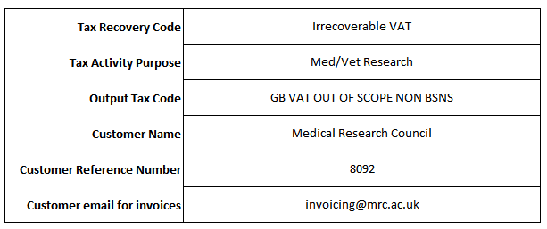
Tax Recovery Code – this section determines whether the VAT incurred on a project is recoverable.

If a project is grant funded and where there is no benefit to the funder, then VAT will usually be irrecoverable and the VAT cost should have been budgeted into the project (select IRRECOVERABLE VAT).

If the intention of the project is to makes a taxable supply (normally back to the funder in the form of a contract for services) then VAT will generally be recoverable. This means there should be no VAT cost to the project (select FULL RECOVERY).

Tax Activity Purpose – this section is used when a project is specifically going to purchase equipment that will be mainly used for medical research. This will enable equipment to be bought VAT free or “zero rated”. This has to be determined when a project is set up (select Med/Vet Research).

Output Tax code – this code determines whether VAT should be charged to our funder/customer. VAT will only be charged to a UK funder/customer when there is a supply of services and the funder/customer is getting something in return for the funds (select GB VAT STANDARD).

Most grant funded projects will be treated as outside the scope of so no VAT is charged to the funder (select GB VAT OUT OF SCOPE NON BSNS).

If we are making a supply to an overseas funder we do not charge them VAT but the VAT on related costs is still recoverable (select GB VAT OUT OF SCOPE RECOVERY).

Any concerns or questions, please contact the Tax Team.

If the Oracle customer reference number or invoicing email address are not known, please leave these fields blank. If the project is internally funded (and no output tax code would be expected), the form will automatically grey out the customer information fields.

NOTE: In instances where departments determine the tax treatment to be anything other than out of scope/irrecoverable, and where the tax activity purpose is anything other than ‘None’, departments must ensure that they receive written confirmation of the tax treatment (tax recovery, output tax and tax activity purpose (e.g. med/vet exemption) codes) from the tax team prior to submission of the project set up request to Research Accounts, and include a copy of the correspondence with the request.

  - Enter any notes that you think might be useful to highlight to Research Accounts in the notes field if necessary (e.g. burdening requirements, amount/GL string location of funds already received if applicable, etc):

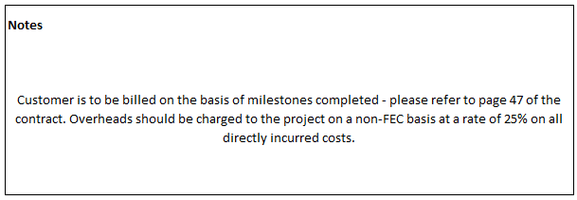

  - Please indicate who the form has been completed by, and what date the form was completed on. Please also ensure that the ‘Approved by’ field is completed by either the Head of Unit or the relevant person to whom their authority is delegated within your department/division, consistent with the policy outlined in the University’s Financial Regulations (see point 1.5 (g) and (h) -https://finance.web.ox.ac.uk/financial-regulations):

In addition to these fields being completed, please also ensure that the involvement of the approver is evidenced in the submission of the set up request to Research Accounts. This could take the form of one of the following options:

- The approver forwards the request directly to Research Accounts, or;
- The approver is copied in on the email submission to Research Accounts, or;
- An email trail is either appended or attached to the request in which the approver indicates confirmation of their approval.

  - Please answer the three questions towards the bottom right hand corner of the form concerning tax treatment, currency code (if it isn’t GBP), and any capitalisation treatment (if applicable):

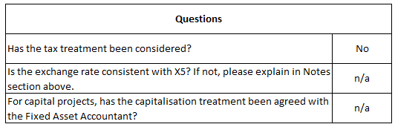

Note that the question concerning tax treatment will change depending upon the treatments entered for the project (see section 1.c):

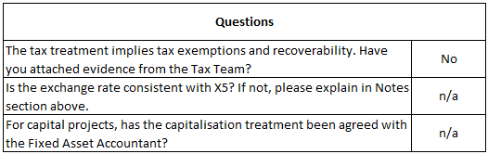

- On the second worksheet (titled ‘DETAILS’), please complete all of the fields, one row per budget resource, for as many tasks as required. Any red fields indicate that the data entered is either missing or incorrect:
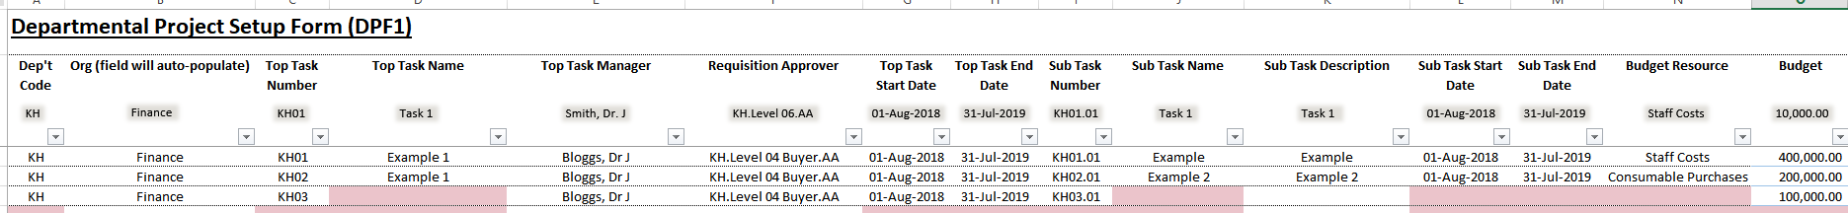
  - Task name and description field lengths: please note that top task and sub task names are restricted by the system to a maximum of 20 characters in length. Task descriptions are limited to a maximum of 250 characters.

  - Please note that when assigning task managers to top tasks, please ensure that the relevant persons are set up in CoreHR. If the relevant persons are not yet listed on Oracle, please provide the person’s employee number in the ‘Notes’ section on the ‘FRONT PAGE’ worksheet. Research Accounts will then request for a person record to be set up on Oracle, and then assign the relevant person as the top task manager accordingly. In the interim, the default placeholder task manager of ‘Mr Principal Investigator’ will be used until the setup is complete.

  - Please note that all fields are mandatory except the ‘Sub Task Description’ field. The requisition approver field can also be left blank if requisitions are to flow to the top task manager (who should be in a relevant approver position) in the first instance.

  - For the requisition approver field, please note that the requisition approver is only effective at top task level. Therefore, different requisition approver positions cannot be applied to different sub tasks under the same top task. Should a different requisition approver position be required for a given sub task, please ensure that this is placed under a different/new top task:

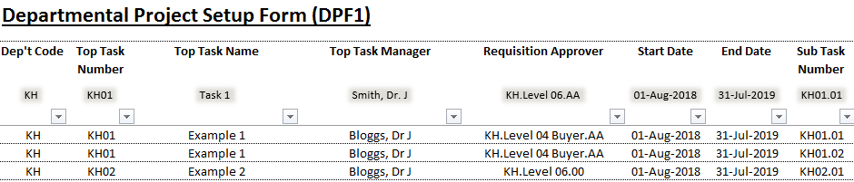

Once the above steps have been completed, the spreadsheet should be sent to Research Accounts at dept.projects@admin.ox.ac.uk (non-studentship projects) or studentships-ra@admin.ox.ac.uk (studentship projects) for processing.

