Adding comments at any level of payroll main planning view
It is possible to add comments under any level of the above cube, not just at the posting level. This is done by:
- Right click on the comment cell you want to use:
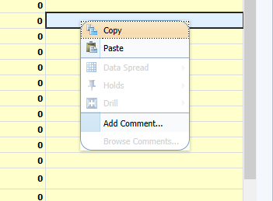
- Select “add comment”:
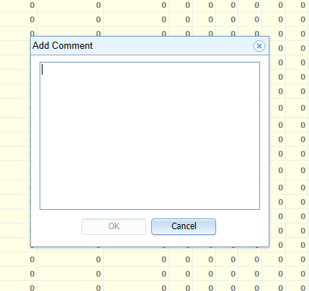
- Enter your comment and press OK. Note that there is a 150 character limit on what is displayed, even though more can be entered in the comment box. If you exceed 150 characters then the final 150 characters are displayed.
- The comment appears in blue in the cell:
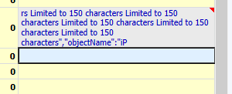
- You then commit the change using the tick, after which the comment turns black and the formatting at the end disappears.
- You can overwrite your comment by adding a new one and use the “Browse comments” option to see old comments.
NB Once a comment is entered, there always needs to a comment in the cell, so if the comment was no longer required, users would have to enter “.” or similar.
NB it is NOT possible to copy the comments from forecast to forecast as a starting point so they will relate to a single version only.

