How to import Month-End calendar dates from Excel to Outlook
- Download the relevant Excel file from the webpage and make a note of the file location you save this to. The file should be saved in .csv (Comma Separated Values – comma delimited) format.

Note - Appointments are set for half an hour at 5pm on the deadline date with a reminder two days before at 9am (with the exception of Project journals which have a deadline of 1pm and a reminder at 12noon three days prior). The time is set to show in your calendar as “Free”.

It is possible to edit the length of appointments, or the date and time of the reminders in your saved file if you wish. When opening the .csv file the columns will be compressed, please expand the columns to read the data. Reminders can be adjusted in columns H (date of reminder) and I (time of reminder). It is possible to adjust individual appointments and reminders once in your calendar as normal.

- In Outlook go to “File”:
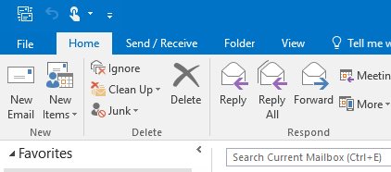

- Select “Open & Export”
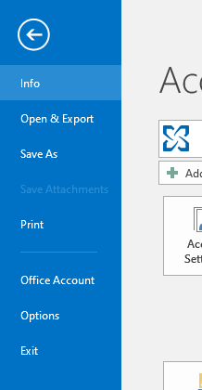

- Select “Import/Export”
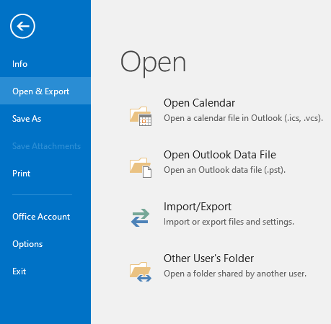

- Select “Import from another program or file” and press “Next >”
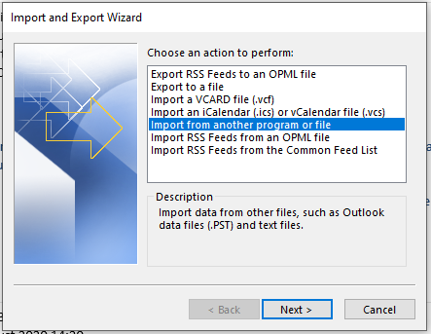

- Select “Comma Separated Values” and press “Next >”
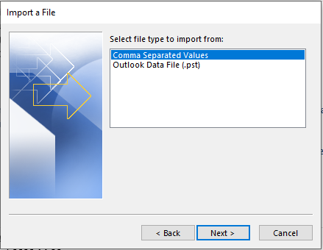

- Select “Browse …” and choose the file location you saved the Excel file to and press “Next >”
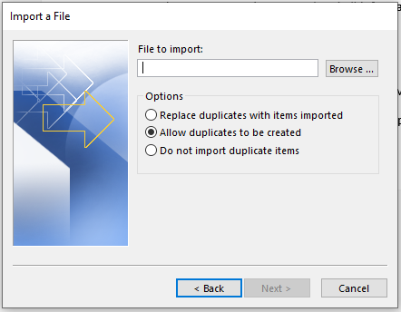

- Select your calendar and press “Next >”
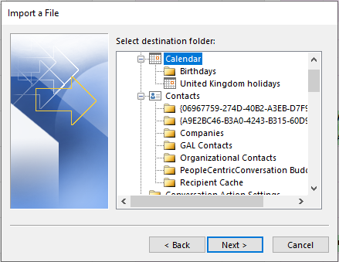

- Ensure the Import box is ticked and press “Finish”
